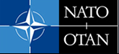 | Information for Visitors to NATO HQ  (Brussels, Belgium) | 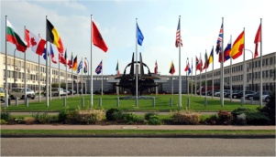

How to get to NATO HQ
NATO is located at: Boulevard Léopold III, 1110 Brussels
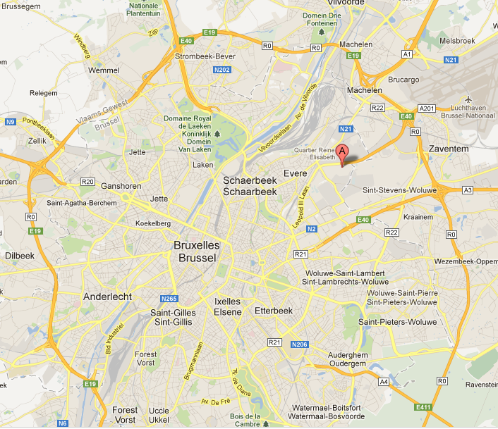
For Google Maps enter: Noord-Atlantische Verdragsorganisatie 1110 Bruxelles, Belgique

Arrival by Car:
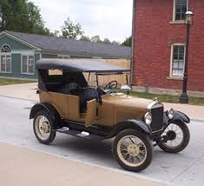 | When using a Navigation System, look for Avenue du Bourget 44, 1110 Brussels (or Bourgetlaan 44). It brings you close to the NATO HQ Main Gate.

Please be aware that you will have to park outside NATO HQ and that there is only limited parking space available in NATO´s proximity. The picture below shows the entrance to the (small) Visitor Car Park at the Main Gate.

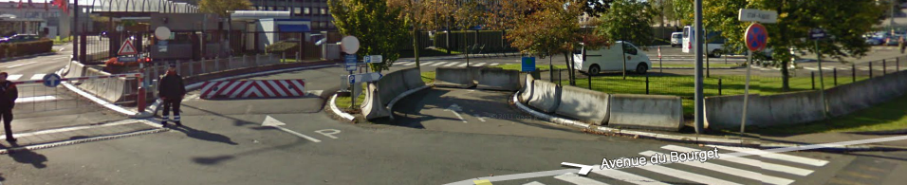

Arrival by Airplane:
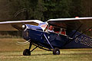 | Brussels Airport To & From:  http://www.brusselsairport.be/en/passngr/to_from_brussels_airport/  Brussels Airport is located at Zaventem, about 5 km northeast of NATO HQ, and you can choose from various bus lines.

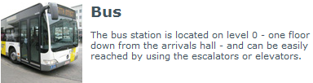

The bus company De Lijn operates bus services to NATO (lines 272, 471 and 620) and to railway station Brussels North (lines 272 and 471) and the Brussels underground station Roodebeek (lines 359 and 659).
De Lijn Home Page: http://www.delijn.be/en/index.htm

The MIVB/STIB busses provide a 30-minute express service (line number 12) between Brussels Airport and the European quarter. It operates from Monday to Friday 8 pm and only serves the major stops. NATO is the first stop!

On weekdays after 8 pm, and the whole day on Saturday, Sunday and holidays the Airport Line is operated as a regular service with number 21, serving all stops.

All MIVB/STIB buses depart from platform C.
In order to save time and money, buy your ticket from the GO ticket vending machines before boarding. These machines accept Maestro bank cards, credit cards and coins.
- For 1 journey (purchased outside vehicle): 4,00 €
- For 1 journey (purchased inside vehicle): 6,00 €
- For 10 journeys: 27,00 €

For more information on MIVB/STIB buses: http://www.mivb.be/airport-line.html?l=en

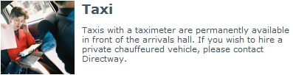

The fare from the airport to NATO HQ is normally about € 15, to the city centre of Brussels around € 45. Licensed taxis can be recognized by the blue and yellow emblem. Travellers are advised to avoid unlicensed taxis!

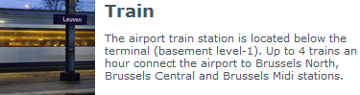

There is NO stop for NATO HQ.
There are direct train services to the East, South, West and North of Belgium.
Approximate travel times to:
- Antwerp: 37 minutes
- Brussels Central (city centre): 17 minutes
- Ghent: 54 minutes
- Leuven: 15 minutes
- Mechelen: 11 minutes
- Mons: 75 minutes

Arrival by Train:
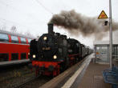 | Information on Belgian Rail: http://www.belgianrail.be/en/Default.aspx  Brussels has three train stations: Central, North and South (“Midi”)

Gare Centrale (Central Station) or Place de Brouckére

- There is no metro to NATO.
- The two buses which serve NATO are 65 and 21.
- Take No. 65 or 21 bus, direction “OTAN/NAVO”.
- The ticket costs €1,40 and it takes about 45-60 minutes, depending on traffic conditions.
- See the website http://www.stib.be/index.htm?l=en for further information or call +32 2 515 2000.
- A taxi costs approximately €15 and takes about 10-20 minutes.

Gare du Midi (South Station)

- By metro, take Line 2, direction “Simonis” and get off at “Place Madou”.
- Follow the signs for the No 65 bus, which will be marked “OTAN/NAVO”.
- Ticket costs €1,40. Journey lasts about 60 minutes. The No. 65 runs about every 10 minutes.
- Another possibility is to take a tram No 52, 55, or 81 from Gare du Midi, direction Gare du Nord (North Station) and get off at the 4th stop called Gare de Brouckère.
- From there you may catch the No. 65 bus to NATO. The No. 65 bus also stops at Gare Centrale (Central Station).
- By taxi the journey costs approximately € 17 and takes about 25-45 minutes, depending on traffic conditions.

Gare du Nord (North Station)

- Take the tram No. 90, direction “Gare du Midi/Zuidstation” and get down after one stop at Place Rogier.
- Change to metro line no. 2, direction “Clemenceau” and get down at Place Madou.
- Follow the signs for the No. 65 bus stop which will be marked “OTAN/NAVO”.
- Ticket costs €1,40 and the journey lasts about 60 minutes in total.
- A taxi costs approximately € 13 and takes 10-20 minutes, depending on traffic conditions.

How to enter NATO HQ (IMPORTANT)
- In order to enter NATO HQ premises, you must have a valid pass.
- Please contact the security officer of your national delegation at NATO HQ at least one week in advance to go through the necessary formalities.
- If you come from a European Union institution, please check with your organization´s security officer whether he can take care of this on the basis of a special security agreement with NATO, otherwise contact your national delegation at NATO HQ.
- You should enter at the access for pedestrians where your name will be checked.
- If your name is on the list supplied by the delegations for attending a meeting, your pass may be collected at the main gate security desk on arrival at NATO. You will be asked to leave your passport or identity card in exchange for this pass. If your name is not on the list, you will need to be escorted throughout your stay at NATO HQ.
- Please be aware that the International Staff is not responsible for the delivery of your pass. Do not send any security clearances to the secretary of the meeting, he is not authorized to deliver passes.
- Send your security clearance information to your National Delegation at NATO, by fax, at least one week in advance (it takes 4 days to deliver a certificate). Please indicate the following on the Subject field of the request form: Name of the Meeting + Date of the Meeting + POC at NATO (Secretary of Meeting + Phone Number). This information will then be passed to NATO HQ Visitors/Pass Office in order that you should receive a pass when you arrive at NATO HQ.

National Delegation at NATO HQ | Fax Number  Attn: Security Officer | Security Officer Extension
Albania | +32 (0)2 707 2783 | 2780
Belgium | +32 (0)2 707 6090 | 6072
Bulgaria | +32 (0)2 707 2820
Canada | +32 (0)2 707 7148
Croatia | +32 (0)2 707 2462 | 2074
Czech Republic | +32 (0)2 707 1769
Denmark | +32 (0)2 707 6115
Estonia | +32 (0)2 707 9590
France | +32 (0)2 727 7432
Germany | +32 (0)2 726 4948
Greece | +32 (0)2 726 8030
Hungary | +32 (0)2 707 1763
Italy | +32 (0)2 707 6259
Latvia | +32 (0)2 707 9748
Lithuania | +32 (0)2 707 2850
Luxembourg | +32 (0)2 726 8900
The Netherlands | +32 (0)2 726 7801
Norway | +32 (0)2 726 5630
Poland | +32 (0)2 707 1366
Portugal | +32 (0)2 707 6427
Romania | +32 (0)2 707 9602
Slovakia | +32 (0)2 707 2742
Slovenia | +32 (0)2 707 2955
Spain | +32 (0)2 707 6537 | 6513/6510
Turkey | +32 (0)2 707 6833
United Kingdom | +32 (0)2 707 7596
United States | +32 (0)2 724 3403 | 3265 / 3254

How to find the Conference Room
- The conference rooms are situated inside the main building, after the security desks.
- The room number for your meeting will be notified on electronic boards as you enter the conference room area and in the foyer.
- The Headquarters conference rooms are equipped with computer workstations. The workstations have the capability to connect to the Minerva network or operate in stand-alone mode, depending upon security considerations and requirements for the meeting. Upon request, an internet connection can be made available.
- Standard MS Office software is available.
- Presentations may be uploaded from CD-ROM/DVD or USB-stick.
- Preferably presentations should be provided to the Secretary for upload 2 days prior to the meeting.
- Laptops/Notebooks may be operated during the meeting on battery power only and with WLAN turned off. (WLAN is not available in the conference area.)

Security Regulations applying to Conference Rooms
- As stated in the NATO HQ Security Regulations and IMSSOP 2, it is not permitted to bring and/or use any type of transmission equipment, in particular mobile phones and blackberries, into the conference rooms.
- You should be aware that mobile phones and blackberries - even when switched off - are still able to transmit electronic signals, such as those produced by the microphone and speaker systems in the meetings rooms, over significant distance, i.e. well beyond the walls of the conference rooms. Surely you would not wish your deliberations to be heard by those not permitted to attend the meetings.
- When Laptops/Notebooks are being used in conference rooms, their WLAN/WIFI capability must be turned off.
- Please note that you can always leave your electronic devices in a safe at the desk in the Conference Hall (Block L) just outside Room 2. You will receive a receipt and you can easily use your device outside the meeting room during a break if necessary.
- Additionally, lockers are available at the entrance of the conference area on the right.

How to find accommodation in Brussels
- You might find the following websites helpful:
http://www.ebrusselshotels.com/
http://www.brussels-hotels.com/
http://www.hotels.be/
http://www.hotels-belgium.com/
(The “ZIP-code” for Hotels at Brussels Center is 1000. For Hotels closer to NATO HQ it is 1140)
http://www.yellowpages.be
(when prompted, insert “hotels” under “activity” and “Brussels” under “province”)
- Military personnel may contact:
Club Prince Albert
Rue Petit Carmes 20
1000 Bruxelles
+32.3.501.2211

Restaurants
- In the NATO HQ building, you will find
  - a cafeteria (open all day) for drinks, pastries and sandwiches etc.
  - a self-service restaurant (open from 1130 to 1430) for lunch
  - a formal restaurant (behind the cafeteria) for lunch.
- At the NATO Staff Centre you will find a formal restaurant and a bar.
They offer an extensive variaty of different kinds of beverages: cold and hot drinks, beers, wines and spirits. During lunchtime you can also order a snack at the bar (sandwiches, salads, soups, chips and ice creams). The bar is open throughout the year between 10H00 and 21H00. If you wish to make a reservation for lunch or dinner, please call +32 2 707 4800.
- For restaurants in Brussels, try http://en.resto.be/guide-restaurants/city/101-guides-brussels

